TASK 9 – Improving Data Warehouse Refresh

The DM fact table (bl_dm.fct_sales) was recreated using RANGE partitioning on event_dt.
Monthly partitions are used.
Partition management is handled dynamically using a helper procedure which creates and attaches monthly partitions.
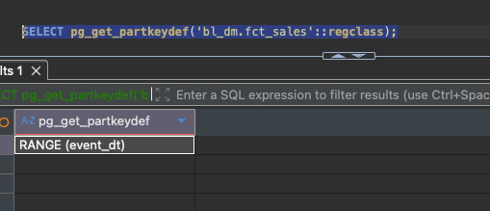
Monthly partitions are created dynamically.
The procedure ensure_month_partition(p_date) creates a standalone monthly table and attaches it using ALTER TABLE … ATTACH PARTITION.
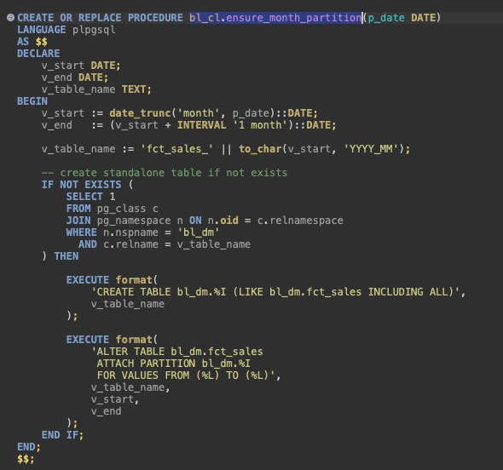

he fact load procedure was modified to implement a rolling 3-month window.
The procedure:
- Calculates the rolling window (last 3 months from CURRENT_DATE)
- Ensures partitions exist for those months
- Loads only rows within that period
- Prevents duplicates using NOT EXISTS
- Logs the number of inserted rows
Business key: (sales_src_id, source_system, event_dt)
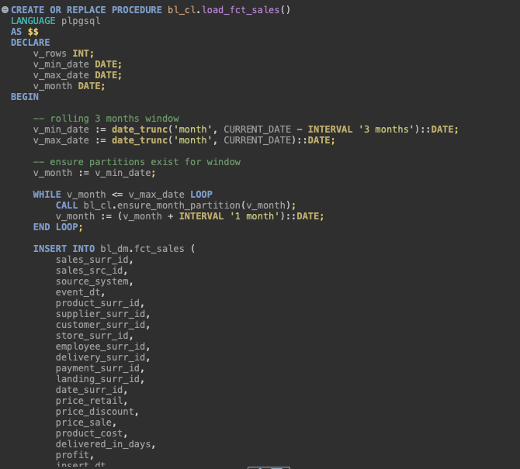
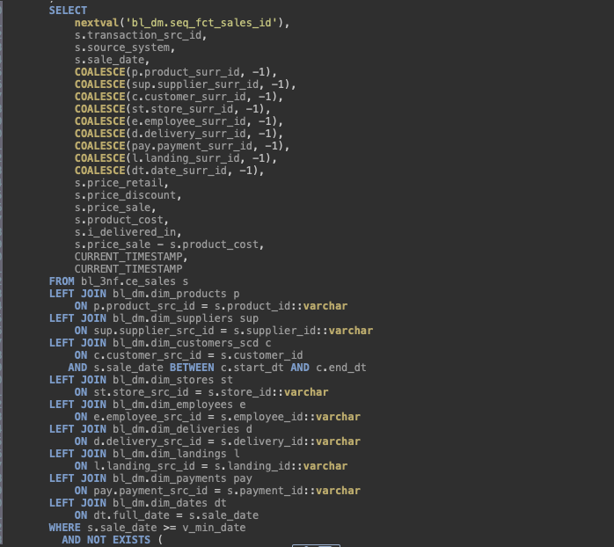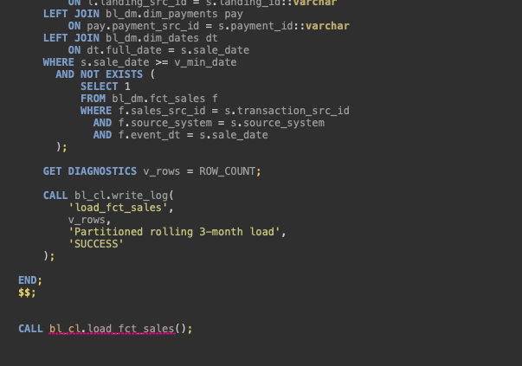

The procedure was executed more than once to verify incremental behavior.
First execution inserts rows within the rolling window.
The following executions insert 0 rows.
This confirms idempotency.
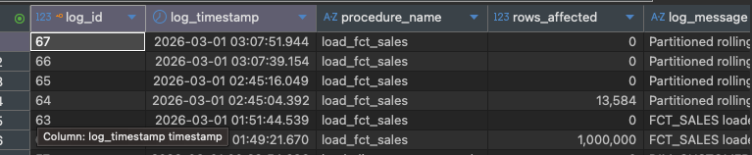
A duplicate check was performed on the business key (sales_src_id, source_system, event_dt) to ensure no duplicate fact rows exist. No duplicates were found.
A completeness test was also executed to confirm that all business keys from 3NF within the rolling 3-month window were successfully loaded into the DM fact table. The result confirmed that no rows were missing.
The solution satisfies partitioning, rolling window refresh, incremental loading, and data consistency requirements.

